Nuneaton Branch Programme 2023-24
Meetings will be on Thursdays at the Chilvers Coton Heritage Centre, 4 Avenue Road, Nuneaton CV11 4LU unless otherwise indicated.
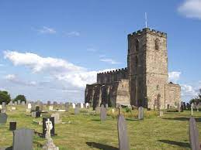
14th September 2023 7.30 pm The Church in a Hillfort: Breedon-on-the Hill
Peter Liddle MBE formerly Leicestershire County Archaeologist

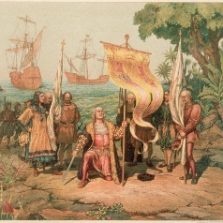
26th October 2023 7.30 pm Colonialism: an assessment
Professor Nigel Biggar, Oxford University

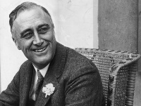
23rd November 2023 7.30 pm FDR: America’s greatest President
Professor Iwan Morgan, University of London

30th November 2023 4.30pm at Etone College Student Great Debate: Which historical place or person from your local area deserves greater recognition?

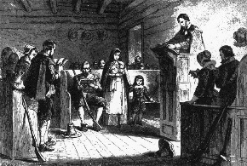
14thDecember 2023 7.30 pm How to get to Heaven in Early Modern England:
Kristi Flake and Anna Pravdica, PhD students, Warwick University

11th or 18th January 2024 7.30pm Espionage in Divided Germany 1945-1990
ZOOM CALL Dr Paul Maddrell, Loughborough University

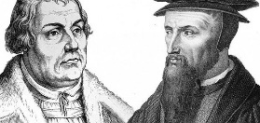
22nd February 2024 7.00pm Remembering the Reformation
Professor Alexandra Walsham, Cambridge University, President of the Historical Association
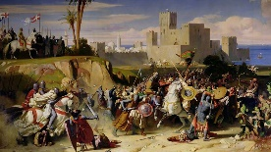
13th March 2024 3.30pm at King Edward VI College,
The Crusades
Dr Natasha Hodgson Nottingham Trent University

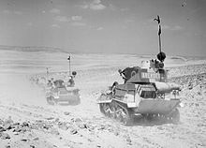
11th April 2024 7.30pm Operation Compass: The First Campaign in the Desert War (1940-41)
Dr Steven Morewood Birmingham University

9th May 2024 7.30pm The Bastille
Professor Munro Price Bradford University

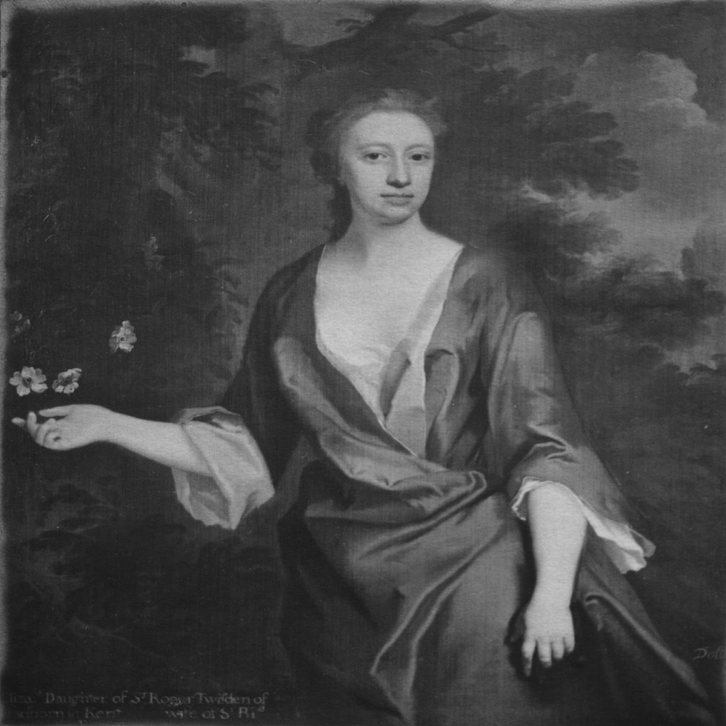
20thJune 2024 7.30pm Annual General Meeting followed by
Two Newdigate Ladies
David Paterson (Nuneaton Branch Chairman)

Summer outings are also arranged and there are second-hand book sales at the meetings. All are welcome to attend. Refreshments are served, usually between the talk and questions to the Speaker.
For further details contact Michael Arnold michael.arnold@cantab.net
or David Patersondjpaterson3@hotmail.com

