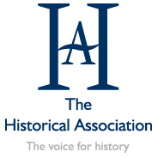
NUNEATON BRANCH OF THE
HISTORICAL ASSOCIATION

Meetings held at Chilvers Coton Heritage Centre on Thursdays at 7.30pm unless otherwise indicated

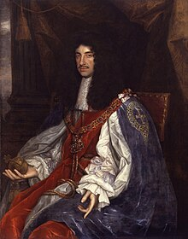
25 September 2025 Years of Struggle: Religious Dissent in the Reign of Charles II: David Paterson

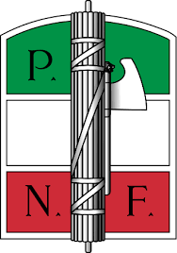
23 October 2025 Italian Fascism: Dr Alex Henry, University of Nottingham

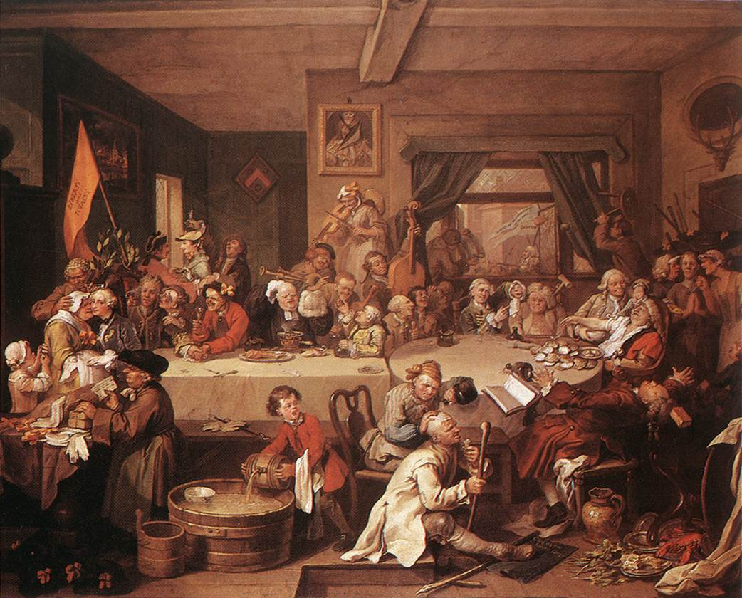
13 November 2025 Democratic constituencies before 1832: Professor Penelope Corfield, Royal Holloway College On Zoom


27 November 2025 The Great Debate: How important are personal and public records as evidence for explaining the story or stories of your local area? [c.4.30 pm] Etone College

4 December 2025 History of Ukraine: Professor Christoph Mick, University of Warwick Attleborough Church Hall
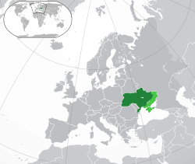

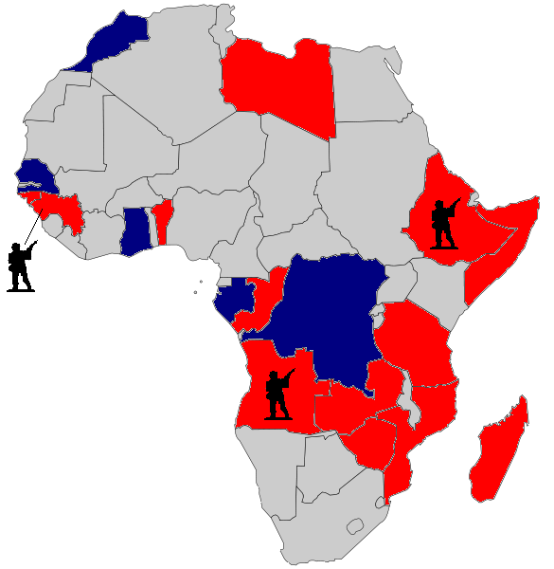
22 January 2026 Africa in the Cold War: Professor Daniel Branch, University of Warwick

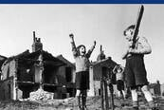
26 February 2026 Sport and the Home Front: Wartime Britain at Play 1939-45: Professor Matt Taylor, De Montfort University

Wednesday 25 March 2026 Germany 1918-1939: Dr Colin Storer University of Warwick
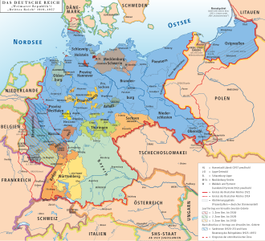
At King Edward VI College Afternoon meeting 3.30 pm

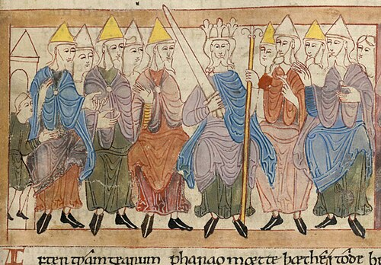
23rd April 2026 The Recovery of the Anglo-Saxon Past: Professor Roey Sweet, University of Leicester

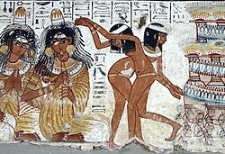
14th May 2026 Religion and the Ancient Egyptians Nicholas Wharton, former Head of History, Lawrence Sheriff School Rugby

June 2026: Date to be arranged: AGM

