Community Food Fleet
23 Hurlbutt Road
Warwick
CV34 6TD

01926 800915
cff@wrccrural.org.uk
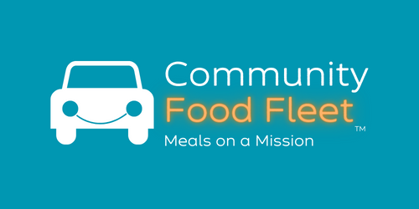

Dear Customer

Thank you for enquiring about our new hot meals service.

Please read through the enclosed information. If you have any questions, please don’t hesitate to contact us:

Phone: 01926 800915

Email: cff@wrccrural.org.uk

We look forward to providing hot meals to you in the near future.

Yours sincerely

The Friendly Team at Community Food Fleet

Enclosed information:
- Leaflet
- FAQ’s
- 4 Week Rolling Menu

FREQUENTLY ASKED QUESTIONS:

How can I order?
- The first few days of meal choices will be taken over the phone. Your delivery driver will deliver menus for future orders on your first delivery day.

How do I pay for the meals?
- Payment method options are cash & cheque to the driver. We will be setting up card payment via phone or online and payment by bank transfer.

Is your service flexible?
- Yes. You can tailor our service to fit your needs. We can deliver between one to seven days a week.
- We can suspend the service at any time. If you want to cancel a meal on the day of delivery, just let us know by 10 am on the day and we’ll ensure that your meal is not delivered and you won’t be charged.

What is the service?
- We deliver hot lunches to members of the local community 365 days per year.
- Our service is to help people with all needs. Drivers will carry out a basic welfare check, help with plating meals and completing menu choices where necessary.

What is the Welfare Check?
- All our friendly delivery drivers are enhanced DBS checked and are trained to carry out basic well-being and safety checks when they deliver your meals, giving you peace of mind. For this reason, we need to see you whenever we deliver a meal.
- We will always keep a next of kin contact details in case we have any concerns or there is no reply at the door. We will contact the next of kin with concerns.

What if I can’t get to the door?
- Many of our customers have limited mobility. Our drivers are used to using key-safe access to customer homes. Our drivers will always call out when they enter the house, so you can rest assured that you know who is in your property.

What time is the delivery?
- We offer a lunchtime service, so your meals will be delivered between 11:30 am and 2:30 pm, depending on where your address fits in with our delivery round. Once you start the service, we can give you a better idea of when your delivery will occur.

What diets can you cater for?
- We offer a variety of soups, main meals and desserts, 7 days a week – 365 days a year. Our menus include dishes from low-fat, low-salt, gluten-free, vegetarian, vegan, and texture-modified meals for those who require softer foods.

If you have other questions, please contact us.

Tel: 01926 800915
e-mail: cff@wrccrural.org.uk

